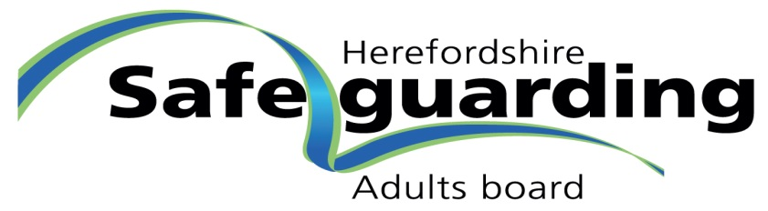

HSAB Policy and Procedures Protocol
Approved by: | HSAB Strategic Board
Date: | September 2021
Date of Review: | March 2023

Overall Purpose
All the key partners of Herefordshire Safeguarding Adults Board (HSAB) have agreed that the regional policy for safeguarding adults should govern all safeguarding work with adults at risk in Herefordshire. The policy, therefore, applies to all professionals and agencies working with adults at risk in the county.

Responsibility for the update of this policy sits with the Regional Editorial Group.

The regional policy is supported by a suite of Herefordshire specific policies. These policies will be developed as required by a group of professionals nominated for the purpose by members of HSAB Strategic Board. Development of policies can be driven by any of the following:
- changes to national frameworks,
- emerging national or local issues,
- in response to local or national consultations
- findings from case reviews or audits or
- other issues.

Development of these policies may require a task and finish group to complete the task.

Where possible this will be done in conjunction with Worcestershire Safeguarding Adults Board.

Responsibility for the review of these policies will sit with members of HSAB, who will nominate the most suitable professional within their agency to perform this duty. All reviews will be carried out remotely.

The Partnership Team, to enable this process, will provide a database of all policies and their review dates to the Board annually. This will form the scheduled work plan for the forthcoming year.

Consultees
The following organisations/sectors should be represented within the group:
- Health
- Local Authority
- West Mercia Police

Third Sector

Independent Sector
- Service commissioners

Dissemination
It is the responsibility of the HSAB Strategic Board member to disseminate any messages arising from this work, such as new policies and procedures, updating existing policies and procedures and areas for common consideration, to all relevant members of their organisation.

It will be the responsibility HSAB Partnership Officer to ensure that any messages are effective and assurance is sought from agencies that these have been cascaded through their internal means.

