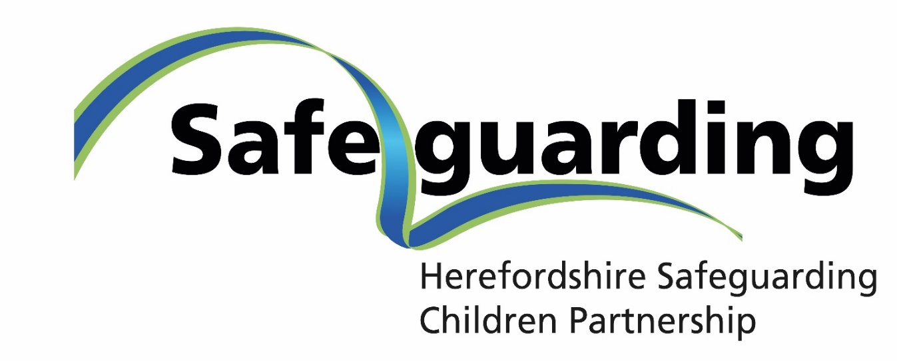

Yearly Review of Effectiveness Report

2023-24



**TABLE OF CONTENTS**

1. Foreword 3

2. About the Yearly Report 6

3. Herefordshire Context 6

4. Our Governance, Membership and Support 7

Governance 8

Membership 10

The Independent Chair and Scrutineer 10

Partnership Team 11

Relationship with other Strategic Partnerships 11

5. Impact of the Strategic Partners Board 11

6. Overview of Activity 2023-24 13

6.1 Performance and Multi-Agency Data 13

6.2 Implementation of Get Safe Approach to Contextual Safeguarding (Strategic Plan Priority) 16

6.3 Strengthening Responses to Childhood Neglect (Strategic Plan Priority) 20

6.4 Effectiveness of the Multi-Agency Safeguarding Hub (Strategic Plan Priority – Right Help Right Time) 22

6.5 Multi-Agency Case Audits and Assurance 24

6.6 Learning from Child Safeguarding Practice Reviews 26

6.7 Multi-Agency Learning and Development Programme 29

6.8 Multi-Agency Professional Differences 32

6.9 Multi-Agency Policies and Procedures 34

7. Voice of Children and Families 35

8. S11 Self-Assessment 36

9. Implementation of Working Together 2023 37

10. Funding 38

11. Our Challenges 38

12. Comment from the Independent Scrutineer 39

13. Priorities moving forward .. 403

Appendix A – HSCP Governance Structure 42

# Foreword

In October 2022 I was appointed as the Independent Scrutineer for the HSCP. I reported in the Annual Report 22/23 on the challenges facing the partnership and that, though progress had been made during the year, the partnership was not effective but had put in place plans for improvement in 23/24. Due to the challenges facing individual partners and Children’s social care in particular it was decided that the Independent Scrutineer would Chair the partnership for 23/24. Whilst this inevitably can lead to the observation that the Independent Scrutineer is now ‘marking their own homework’ it was a pragmatic response to the capacity issues facing the partnership at the time.

This Annual Report sets out the evidence of the impact of the plans made by the HSCP for 23/24 as set out in the HSCP Business Plan.

The new structure implemented in 23/24 has improved the effectiveness of the HSCP in driving forward its agreed priorities. In the main, attendance and engagement of key agencies at the 5 sub-groups has been good. Some attention needs to be given to achieving consistent attendance at the Strategic Partnership Board as indicating in the attendance table in this report.

The Partnership Team review was completed and new appointments made, which has added capacity, capability and stability to the support for the HSCP. The decision to disaggregate support for the Community Safety Partnership is expected to have a positive impact in 2024/25, of enabling the Partnership Team to focus on supporting the HSCP and the Herefordshire Safeguarding Adults Board (HSAB).

The development of a business plan aligned to the Children’s Services Improvement Plan enabled improved working between HSCP and the Improvement Board. This plan set out 4 key priorities for the year:

* Review and implement a Neglect Strategy
* Continue to Improve the MASH
* Review the approach to child exploitation by adopting the Get Safe model
* Implement a trauma informed approach across the partnership

As can be seen in this report the majority of the work required to deliver these priorities was successfully undertaken. If there has been a challenge it was the pace at which these developments were delivered. This has been affected by the capacity of partners in that the work of the HSCP still falls to a relatively small group of staff in partner organisations, but also due to the dependency of some of the work with the need to improve the children’s services information system – MOSAIC.

Nevertheless there have been some key highlights for the year:

1. Launch of Get Safe approach for child exploitation/contextual safeguarding.
2. An updated Herefordshire Child Neglect Strategy (2024-2026) was agreed.
3. Introduction of Understanding Child Neglect multi-agency course, and new tools and resources to support practitioners to identify and respond to child neglect.
4. New offer of Trauma-Informed Practice Training, which was well attended by partners, and Mental Capacity Act training.
5. Launch of the Keep Me Safe Strategy and Keep Me Safe…While I am Sleeping.
6. The effectiveness of the Multi-Agency Safeguarding Hub was validated through both internal and external reviews.
7. Significant progress was made on the development of a multi-agency dataset.
8. Completion of three Rapid Reviews, one of which progressed to a LCSPR that was published in March 2024, with learning and recommendations completed or in progress to improve systems and practice.
9. There is evidence that the multi-agency professional differences policy is being more widely used by practitioners and having a positive impact on the outcomes for children.
10. The partnership has made significant progress towards meeting the requirements of Working Together 2023.

The partnership also took significant steps towards ensuring that there is a good ‘line of sight’ on practice. This has been managed through the Quality and Effectiveness sub-group. During 23/24 the group reviewed:

* 3 multi-agency audits on strategy discussions; child on child abuse; and child sexual abuse. Steps have been taken to ensure the learning from these audits and that from the Rapid Reviews and the Local Child Safeguarding Practice Reviews are taken out to practitioners.
* Performance data has improved and new data provided to the Quality and Effectiveness Group. For example; data was provided on partner’s attendance at Initial and Review Child Protection Conferences, enabling challenge to be made where attendance was not at the right level.
* The multi-agency data set was improved by the addition of data from the Police and the Wye Valley NHS Trust.
* A robust S11 Self-Assessment process was undertaken including partnership challenge sessions chaired by the Independent Scrutineer.

This provides evidence that the HSCP is moving much nearer to the level of evidenced based scrutiny and challenge that helps to improve practice.

It is also worth noting the work that has been done to improve the links between the HSCP and education. The Herefordshire Service Director for Education, Learning and Skills attended the Strategic Partnership Board and provided an update including the outcomes of the S175 annual review of safeguarding arrangements in schools. This attendance has now been built into the new arrangements agreed under WT23 which means that the HSCP will have a stronger relationship with education providers.

Overall the HSCP has made good progress to becoming an effective partnership in 23/24 and as this report shows is also considering its priorities for 24/25 and making plans to consolidate on the achievements of 23/24.

**Kevin Crompton**

**Chair and Independent Scrutineer HSCP**

# About the Yearly Report

**Working Together 2023** requires each Local Authority to establish local arrangements for safeguarding children and young people. In Herefordshire, this is called the Herefordshire Safeguarding Children Partnership. The purpose of these local arrangements is to safeguard and promote the welfare of children, and to work together to identify and respond to the needs of children in the area.

The statutory guidance states that the responsibility for these arrangements is between the Safeguarding Partners, who are Herefordshire Council, West Mercia Police and the NHS Integrated Care Board (Herefordshire and Worcestershire). Other 'relevant' agencies also have a duty to safeguard children and young people under Working Together 2023.

At least once in every 12 month period, the Safeguarding Partners must jointly report on the activity that they have undertaken. This Yearly Report must be published by September of the following year. The focus of the Yearly Report is on multi-agency priorities, learning, impact, evidence and improvement. The report must include:

* What the partnership has done as a result of the multi-agency child safeguarding arrangements, including on child safeguarding practice reviews,
* How effective these arrangements have been in practice.

This Yearly Report of the Herefordshire Safeguarding Children Partnership covers activity between 1st April 2023 and 31st March 2024.

# Herefordshire Context

There are approximately 34,000 children living in Herefordshire, which accounts for 18% of the county’s population (Mid-Year Estimate, 2022). The total population of the county has increased from around 183,500 in 2011 to 188,700 in 2022.

The population is ageing and the proportion of people aged 19 and under has fallen in the past decade from 21.8% to 18%. Herefordshire is less diverse than the country as a whole – 96.9% report their ethnicity as ‘white.’ 84.5% of the local population were born in England – the next most common country of birth was Wales (5.3%) and Poland (1.8%).

As of 2021, Herefordshire is the least densely populated of the West Midlands' 30 local authority areas, and the fourth least densely populated amongst English Upper Tier Authorities.

## Growing up in Herefordshire

Growing up in one of England’s most rural counties presents issues as well as opportunities. For every 100 children in Herefordshire:

**15** would be living in absolute low income families (under 16s) (The Office for Health Improvement and Disparities)

**11** would be from a minority ethnic group (Census 2021)

**15 children** would be claiming free school meals (School Census)

Fewer than **1 child** would be subject to a child protection plan (Children in Need, DFE)

**16 children** would live in households with any of the ‘vulnerability trio’ of domestic abuse, parental mental ill-health or substance misuse; 1 of them with all three risks (Herefordshire 0-19 School Nursing Needs Assessment)

**1 child** would be in the care of the Local Authority (Department for Education)

**19 children** would have special education needs (Department for Education)

**5 children** would have an Education, Health and Care Plan (Department for Education)

**3** would be children from Armed Forces families (Service Children’s Progression Alliance).

**11** Year 4 to Year 6 children would have poor mental health (Children’s and Young People’s Quality of Life Survey 2021)

**12** secondary school children would have a low score on the mental wellbeing scale (Children’s and Young People’s Quality of Life Survey 2021)

**77** children would be at the expected level for early learning goals (Early Years Foundation Stage Profile Results)

**18** children would be classed as persistently absent (School Census)

**1** teenager would be pregnant (Hospital Episode Statistics)

# Our Governance, Membership and Support

The partnership’s current governance arrangements are detailed in the [Multi-Agency Safeguarding Arrangements](https://www.herefordshiresafeguardingboards.org.uk/safeguarding-children-partnership). With the publication of Working Together 2023, the HSCP is working to revise its local arrangements to meet the new requirements. While this work started in 2023-24, it will continue into 2024-25.

The Safeguarding Partners are committed to the HSCP Pledge:

***Our role*** is to keep children safe and give them a voice

***Our commitment*** is to make sure everything we do works for children

***We will*** make sure that children are at the heart of what we do

In 2023-24, the issues affecting children the most and, therefore, our priority areas remained:

* Right Help, Right Time
* Child Exploitation
* Child Neglect
* Leadership & Accountability - Commitment to a high-level improvement plan

## Governance

### Strategic Partners Board

In 2023-24, the safeguarding partnership was held to account by the Strategic Partners Board (SPB), which was Chaired by the Independent Chair and Scrutineer. The Strategic Partners Board (SPB) was formed of the delegated representatives of the three statutory safeguarding partners:

* Director of Children’s Services (Herefordshire Council) – delegated by the Chief Executive of Herefordshire Council
* Superintendent Herefordshire – Local Policing Commander (West Mercia Police) – delegated by the Chief Constable of West Mercia Police
* Chief Nursing Officer (Herefordshire and Worcestershire NHS Integrated Care Board (ICB)) – delegated by the Chief Executive of the Herefordshire and Worcestershire NHS ICB

The Delegated Safeguarding Partners each have a Deputy who also attends the SPB where required, including to represent the Delegated Safeguarding Partner if they are unable to attend.

The Strategic Partners Board’s purpose was to:

* hold the Partnership to account for its performance in ensuring vulnerable children and young people are safe,
* allow discussion of priorities and commitment of resource amongst partners to promote safeguarding,
* identify any major concerns or areas for further investigation by the Partnership,
* agree funding arrangements and budgets for the HSCP.

At the time of writing this report, the role of the Strategic Partners Board is under review due to the new requirements of Working Together 2023 including to reflect the new role of the Lead Safeguarding Partners.

### HSCP Sub-Groups

In 2023-24, the Board was supported by five subgroups that carried out the day-to-day work in order to help deliver the partnership’s Strategic Plan. The subgroups each have a designated Chair and Vice-Chair from one of the three safeguarding partner agencies. These subgroups were the:

* **Quality and Effectiveness Group** – overseeing quality assurance activity, including performance data, multi-agency audits, and s11 self-assessment.

*Chair: Service Director, Herefordshire Council Children’s Services*

* **Joint Case Review Group** – overseeing case review activity for LCSPR, SAR and DHRs.

*Chair: Head of Safeguarding & Designated Nurse for Safeguarding, NHS Integrated Care Board*

* **Development and Practice Group** – overseeing learning and development, policies/procedures, and engagement with children, young people, parents/carers.

*Chair: Principle Social Worker, Herefordshire Council Children’s Services *this post was vacant for much of 2023-24, with the Vice-Chair (Deputy Designated Nurse – NHS ICB) assuming Chairing responsibilities*

* **Child Exploitation and Missing Group** – overseeing the work programme to strengthen responses to child exploitation and contextual safeguarding.

*Chair: Head of Service, Herefordshire Council Children’s Services*

* **MASH Group** – overseeing the effectiveness of the MASH, reports to the Quality and Effectiveness Group.

*Chair: Head of Service, Herefordshire Council Children’s Services*

See Appendix A for a diagram of the HSCP Structure at the end of 2023/24.

During the course of this reporting year, the governance structure underwent a review and changes were implemented to streamline the work of the HSCP. The changes included:

* **Dissolving the Executive Support Group**. This was a multi-agency group which reported to the Strategic Partners Board and to which all other sub groups previously reported. With the dissolution of the Executive Support Group, the SPB assumed these responsibilities, including all sub groups reporting directly to SPB. This change enabled the Safeguarding Partners to have a more direct line of sight on the work of the HSCP.
* **Merging the MASH Strategic and MASH Operational Group**. This change helped to streamline the work of the HSCP by focussing the number of sub-groups and clarifying responsibility. The new MASH Group reports to the Quality and Effectiveness Group.
* **Dissolving the Child Neglect Group,** with the group’s work plan being re-allocated to the Quality and Effectiveness Group and Development and Practice Group. This changed reduced the pressure on group members attending a high number of meetings, and helped to consolidate work around assurance activity or learning/development.

## Membership

In addition to the membership of the three Safeguarding Partner agencies, the HSCP subgroups are supported by a range of relevant agencies, which include:

* Wye Valley NHS Trust
* Herefordshire and Worcestershire Health and Care NHS Trust
* Hereford and Worcester Fire and Rescue Service
* Early Years and Education providers
* West Mercia Youth Offending services
* National Probation Service
* Substance Misuse Services
* Sexual Health Services
* Domestic Abuse Services
* West Mercia Rape and Sexual Abuse Support Centre

The full list of relevant agencies is detailed in the [HSCP Multi-Agency Safeguarding Arrangements](https://www.herefordshiresafeguardingboards.org.uk/documents/herefordshire-multi-agency-safeguarding-arrangements-2023).

Many representatives from relevant agencies are directly involved in the HSCP through membership on the subgroups. The HSCP also remains connected with relevant agencies through communication channels such as the fortnightly Partnership Bulletin, multi-agency training programme and learning events, and the partnership website.

## The Independent Chair and Scrutineer

An Independent Scrutineer was appointed by the partnership in October 2022. The Independent Scrutineer provides a rigorous and transparent assessment of the extent to which appropriate and effective systems and processes are in place in all partner agencies so as to fulfil their statutory duties and ensure that children are protected and that appropriate safeguarding strategies are developed and embedded.

Key to this is the facilitation of a working culture of transparency, challenge and improvement across all partners with regards to their safeguarding arrangements. The Scrutineer is accountable to the Chief Executive of Herefordshire Council. He has retained a ‘right to roam,’ challenging the safeguarding partners and all relevant partners and agencies listed in our multi-agency arrangements.

In 2023-24, the Independent Scrutineer was asked by the Safeguarding Partners to also act as Independent Chair for the Strategic Partners Board, which is a role he assumed from March 2023 until April 2024. In April 2024, the Director of Children’s Services, as the Delegated Safeguarding Partner for Herefordshire Council, assumed the Chairing role in line with requirements of Working Together 2023.

## Partnership Team

The HSCP is supported by the Partnership Team. In 2023-24, this team was made up of a Partnership Manager, a Deputy Manager, 2 Partnership Officers and 1.5 Partnership Support Officers. The Partnership Team also supports the Herefordshire Safeguarding Adults Board and Herefordshire Community Safety Partnership. They ensure the smooth running of the partnership’s day-to-day business, providing logistical support, administration and development support.

In 2023-24, one post in the Partnership Team remained vacant (Partnership Administration Coordinator), in order to fund the costs of an agency Partnership Team Manager. This post has now been recruited to in 2024-25 and a permanent Partnership Team Manager also appointed.

## Relationship with other Strategic Partnerships

The HSCP does not operate in isolation, and there are a range of other multi agency partnership arrangements, which contribute significantly to the children’s and adults safeguarding agenda.

With a shared Partnership Team, the HSCP has close ties with the Herefordshire Safeguarding Adults Board and Community Safety Partnership. HSCP representatives are also invited to the Health and Wellbeing Board, and the HSCP Annual Report is shared with both the Health and Wellbeing Board, and the Children’s Scrutiny Committee.

In 2023-24, the HSCP and Herefordshire Safeguarding Adults Board began work on a transition pathway for young people at risk of exploitation. The HSCP has also worked with the Community Safety Partnership in response to the findings of the Independent Commission to Consider Families’ Experiences, in relation to improving the response to children and families affected by domestic abuse.

The HSCP has equally established close ties with the Children’s Services Improvement Board, including aligning its strategic priorities for 2023-24 with the Improvement Programme. This has enabled the partnership’s contribution to improving services for children and families to be transparently reported.

# Impact of the Strategic Partners Board

The Board met four times over the course of the year. While there was representation from each of the Safeguarding Partner agencies at every meeting, this was occasionally from a Deputy for the Delegated Safeguarding Partner, or another representative.

|  |  |  |
| --- | --- | --- |
| **Safeguarding Partner Agency** | **Representation** | **% of SPB meetings attended** |
| Herefordshire and Worcestershire NHS ICB | Delegated Safeguarding Partner (Chief Nurse) | 50% |
|  | Deputy Delegated Safeguarding Partner or a Representative | 75% |
| Herefordshire Council | Delegated Safeguarding Partner (Director of Children’s Services) | 100% |
|  | Deputy Delegated Safeguarding Partner or a Representative | 100% |
| West Mercia Police | Delegated Safeguarding Partner (Superintendent Herefordshire) | 50% |
|  | Deputy Delegated Safeguarding Partner or a Representative | 50% |

In addition to overseeing the regular business of the HSCP, the Strategic Partners Board made a number of key decisions during 2023-24, including:

* **Commissioning a learning review for the “M” Family**, which was Chaired by the Independent Chair and Scrutineer. This was a historical case, dating back a few years, where allegations of abuse were made during court proceedings in relation to the children’s previous foster carer. The review sought to understand how robustly the allegations were investigated at the time, if any risk remained to children from the foster carer, and identify learning in relation to managing allegations. The review found that, while there was a failure in information sharing, complaints procedures, and understanding of the role of the advocacy service at the time, there were no ongoing risks to children from the foster carer and that appropriate systems have now been put in place by Herefordshire Council that will mitigate against the chances of a similar situation occurring again.
* **Led the partnership response to the Report of the Independent Commission to Consider Families’ Experience of Children’s Services in Herefordshire.** This was an independent commission, comprised of a panel of three independent experts, which was initiated by the DFE Children’s Services Commissioner for Herefordshire and taken forward by the Herefordshire Safeguarding Children Partnership. The HSCP Independent Scrutineer also sat on the commission as an observer. The independent commission heard from twenty individuals, one of whom was a young person, who had a range of experiences with Children’s Social Care, Adult Social Care, the police, health and mental health services, and specialised independent services. The report of the commission was published in June 2023. Four of the recommendations were address to the HSCP, with respect of assurance and strengthening of multi-agency working. In response, the HSCP devised a robust action plan that focused on 1) strengthening quality assurance activity, 2) assurance from the Community Safety Partnership in response to domestic abuse, 3) enhancing the learning offer around trauma-informed practice, restorative practice, and Think Family approaches, and 4) assurance of agency complaints, whistleblowing and management of allegation procedures.
* Worked to **align the HSCP Strategic Priorities with the Children’s Services Improvement Programme**. This resulted in better communication and coordination between the HSCP and Children’s Improvement Programme.
* **Organised two “Working Together 2023 Health Check” sessions**, facilitated by the DFE National Advisor, and oversaw the development of a robust implementation plan for Working Together 2023.
* In recognition of the complexities of the partnership governance arrangements and the need to test out the extent to which these arrangements were effective in practice, a **Back to Basic workshop** was held in June 2023 with key partners from both the HSCP and Herefordshire Safeguarding Adults Board. The recommendations were implemented throughout 2023-24, which has enabled a more robust and streamlined governance approach.

# Overview of Activity 2023-24

Below is an outline of what the partnership achieved in 2023-24, as well as challenges and impact.

## 6.1 Performance and Multi-Agency Data

At the beginning of this reporting year the decision was taken to build an initial multi-agency dataset which was succinct and made use of data and reports already in place within partner agencies. This would then form the basis from which a more comprehensive dataset could be developed. As a result of this work, the Quality & Effectiveness Group now has a dataset which incorporates information from Herefordshire Children Social Care, Wye Valley NHS Trust and West Mercia Police. The Partnership is now able to see:

* contacts and referrals by source and conversion rates,
* strategy discussions and agency contributions,
* strategy discussions resulting in Section 47 enquires,
* assessment outcomes,
* numbers and categories of Child Protection Plans, and
* children being privately fostered.

In addition, Wye Valley NHS Trust data provides information such as:

* Health Visitor and School Nurse attendance at Initial and Review Child Protection Conferences,
* reports presented to Child Protection Conferences,
* the number of Child Protection Medicals and Health Assessments completed,
* safeguarding training and supervision, and
* referrals to the Local Authority Designated Officer.

In relation to Police data, the Q&E Group now receives the Herefordshire Partnership Crime Data spreadsheet (which is a regular submission to the Herefordshire Community Safety Partnership, and includes child and young person data) and has also received the recently published Herefordshire Knife Crime Problem Profile (which also contains data specific to children and young people).

**Impact:** We now have a multi-agency dataset, which provides detailed information on agency contributions at different stages of the child protection process. This provides the partnership with an overview of child protection activity, which enables us to identify priorities and target activity.

## What does our data tell us?

Safeguarding data in 2023/24 generally shows a positive trend in improving the services and support for children and families, although many areas are still disproportionate when compared with Herefordshire’s statistical neighbours. As Herefordshire builds its multi-agency dataset, additional information is becoming available from partners to supplement the safeguarding data from Herefordshire Council.

**Early Help**

The Early Help Children’s Help and Advice Team (CHAT) completed 4957 contacts in 2023-2024, an increase of 34% compared to 2022-23.

In January 2023, CHAT introduced a telephone line for families and professionals to call for support. In 2023/24, 1313 calls were taken, approximately 50% from families. The impact of the increase in contacts and the telephone line has meant that even though the majority of contacts, 72.8% were completed in timescale, the target of 95% completed in 72 hours was missed.

There is good engagement from partners with Early Help Assessments, with 67% of Early Help Assessments being completed by partner agencies in 2023/24. This was commended by the Supporting Families representative at a recent meeting as it is a high proportion when compared with other local authorities.

**MASH Contacts and Referrals**

The overall number of Contacts to the MASH increased slightly for the year, by 2.7%, compared with 2022/23. The number of contacts remains high in comparison to our statistical neighbours.

Approximately 20% of Contacts progress to a Referral, which is down from 28% in 2022/23. The police remain the highest referrers, representing approximately 40% of all contacts, however of these only 12% of police contacts progressed to a referral.

Work has been completed with the MASH team to define what constitutes a Contact and there is an increased management oversight on the progression of Contacts. Discussions have also started with police regarding the rate of referrals and application of thresholds.

**Strategy Meetings**

The volume of strategy meetings decreased in 2023-24, when compared with 2022-23. Threshold and strategy meeting training was delivered by the MASH Service Manager, which has seen an improvement in the application of thresholds for progression to s47 Enquiries, and oversight by the Service Manager is taking place to ensure meetings are being convened to a good standard, SMART plans are being implemented, and accurate threshold decisions are being made.

The timeliness of Strategy Meetings has fluctuated throughout the year, from between 80-96% completed on time, however at the end of the year 96% of Strategy Discussions were completed in time.

Agency involvement in Strategy Meetings was identified as a potential issue during the year, with data reports showing a low number of Strategy Meetings with a Health representative in attendance. However, further enquiry confirmed that this was a data reporting issue, rather than an attendance issue.

**Completed Assessments**

The percentage of Assessments completed in timescales (45 Days), is below the target. 79% of Assessments were completed within timescales, where the target is 95%. This was due to fluctuations in staffing, but with staffing stabilised towards the end of 2023/24, there is an increased focus on the timely conclusion of assessments.

The rate of assessments per child in Herefordshire has significantly decreased in 2023/24 compared with 2022/23 – by nearly half – and is lower than the rate for statistical neighbours. This reduction is the direct result of a concentrated effort to increase management oversight of referrals and more proportionate consideration of the need for an assessment.

**S47 Enquiries**

The rate of s47 enquiries per 10,000 children continues to fall from 371 (2022/23) to 269 for 2023/24, however this is still higher than out statistical neighbours. 36% of s47 enquiries progressed to an ICPC.

**Children in Need**

The rate of children with a Child in Need Plan per 10,000 children has reduced from 105 in 2022/23 to 88 for 2023/24; this is more in line with other Local Authorities in the West Midlands. A Practice Forum in February regarding CiN processes, timescales, visits on time, wishes and feelings, SMART planning has set clear expectations with practitioners.

**Child Protection**

At the end of March 2024, there were 204 children subject to a Child Protection Plan. The number of children on a CP Plan is lower than last year but rose for 5 months from June 2023. The rate (per 10,000 children) of children on CP Plans remains high when compared with our statistical neighbours.

Emotional Abuse was the most prevalent category of abuse for children on a CP Plan, followed by Child Neglect. Sexual Abuse and Physical Abuse represent a small proportion of reasons for a CP Plan.

An issue was raised in 2023/24 regarding quoracy at CP Conferences, with Children’s Social Care reporting that some Review Child Protection Conferences had to be cancelled due to lack of attendance from partner agencies. In response, the Independent Chair and Scrutineer wrote to partners to emphasise the importance of attendance at conferences. The requirements for attendance were clarified and Children’s Services reviewed its Business Support processes to ensure that invitations were being sent to the correct people, and responses tracked. The HSCP Quality and Effectiveness Group is continuing to monitor attendance and quoracy at ICPC and RCPCs.

**Children in Care and Leaving Care**

During 2023/24, 98 children came into the care of Herefordshire Council, whilst 119 children left care. While the rate of children in care in Herefordshire (per 10,000), has gradually reduced, it remains high when compared with our statistical neighbours.

A significant majority (94.3%) of Herefordshire’s Care Experienced young people aged 19-21 live in suitable accommodation. There is regular oversight by the Corporate Parenting Service of young people who are not in suitable accommodation.

The proportion of care experienced children in education, employment or training (EET) is low (54.1% for those aged 19-21), and whilst this is in line with our Statistical Neighbours (55.2%) we need to focus on improving this by ensuring apprenticeships, work experience and employment opportunities with the local authority and our partners are maximised in the future.

## Implementation of Get Safe Approach to Contextual Safeguarding (Strategic Plan Priority)

In 2023-24 the HSCP has seen a strengthening of commitment and engagement on ensuring Herefordshire’s response to children and young people affected by exploitation is effective. This work was driven by the Child Exploitation and Missing Group.

Following the Ofsted Inspection in July 2022, a review of MACE arrangements was completed. After discussions with neighbouring authorities, it was agreed that Herefordshire would move towards adopting the GET SAFE Model, successfully used in Worcestershire and Devon.

GET SAFE is a multi-agency approach to triage, assess and reduce the risk to young people from being exploited. GET SAFE is a contextual method of working, assessing the risk factors outside the family home that influence and impact on young people. The contextual approach enables practitioners to understand the full holistic picture of risk and not inadvertently penalise a family and child/young person when the young person is being targeted and groomed by external factors due to matters beyond the control of the family, where the family may have relentlessly been trying to keep their child safe. GET SAFE aims to provide a complete pathway of support along the Right Help Right Time, Levels of Need continuum.

The GET SAFE programme commenced implementation in late 2022 with project management resource and a task and finish group meeting fortnightly with a clear implementation plan. The GET SAFE approach was then fully adopted in January 2024, with the launch taking place at the Contextual Safeguarding Conference on 30 January 2024.

The remit of the Safe Team has extended to include having oversight of all children in Herefordshire who are at risk of:

* Gangs
* Child Sexual Exploitation
* Trafficking
* Modern Day Slavery
* Absent or Missing
* Forced Marriage
* Criminal Exploitation
* County Lines
* Honour based violence
* Female Genital Mutilation (FGM)
* Radicalisation

All Exploitation and Contextual Safeguarding policies/procedures, and training, were updated to reflect GET SAFE. Leads from a range of partner agencies also completed a train the trainer session and then delivered training to relevant staff within their organisations.

### The GET SAFE Launch

Hereford Racecourse was the venue for the HSCP Contextual Safeguarding Conference January 2024 and the launch of the GET SAFE Herefordshire response to child exploitation and contextual threats facing children and young people.

160 delegates attended the event and heard from speakers covering: Get Safe, substance misuse, county lines, prevent and radicalisation, contextual safeguarding, serious violence and several very moving and inspirational lived experience presentations. The opportunity was also taken to raise awareness around the Prevent agenda in recognition of the link with vulnerabilities and radicalisation.

Delegates completed 88 evaluations with many listing multiple favourite speakers. This feedback will be used to inform next year’s conference.

A [highlights film of the Herefordshire Contextual Safeguarding Conference 2024](https://www.youtube.com/watch?v=nG001IHXgjc) illustrates the energy and enthusiasm of the event.

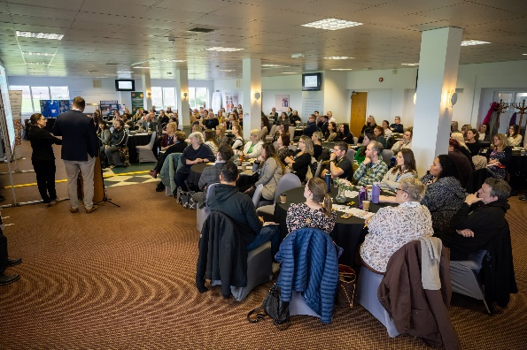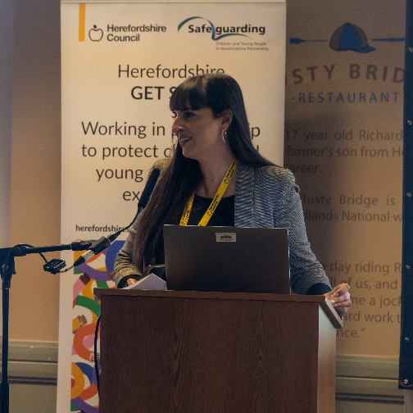*Images from the Herefordshire Contextual Safeguarding Conference – 30 January 2024*

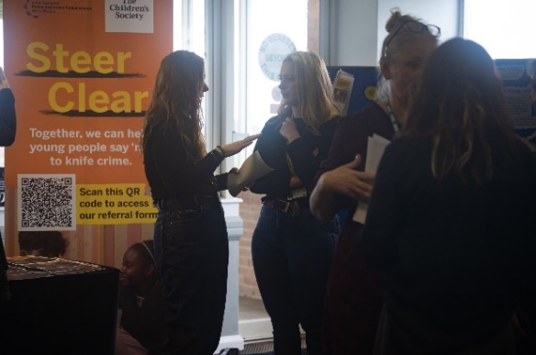

### National CE Awareness Day – 20th March 2024

To celebrate National CE Awareness day on the 20th March 2024, Herefordshire Council held an event at Plough Lane Atrium with our young people, the “Safe Cadets” leading on this event. It was a great event and our young people did exceptionally well on the day.

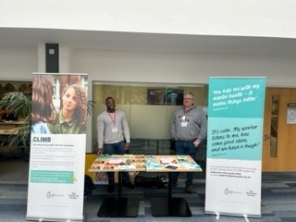 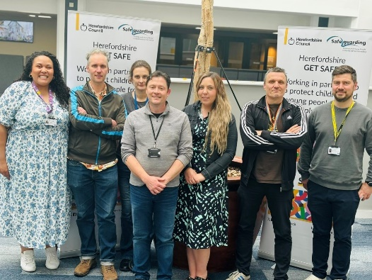

### MACE 2 Prevent and Disrupt Group

The Herefordshire Prevent and Disrupt group (MACE 2) continued to meet monthly during 2023/24. It has identified hotspots, perpetrators and groups of vulnerable young people. After a review of practice it was concluded that the term Prevent and Disrupt was confusing and is not the term used nationally, and therefore MACE will be used going forward.

### Adult Exploitation and Transitions

Following the implementation of the GET SAFE model, the Herefordshire Safeguarding Adult Board have agreed a proposal that will introduce a standardised response to Adult Exploitation that also includes care leavers. In 2024-25, the HSCP is working with the Herefordshire Safeguarding Adults Board to strengthen the transition pathways for young people at risk of exploitation.

### Child Exploitation Data

It is difficult to make a comparison with the data from the previous 2 years, due to the reporting systems and new GET SAFE model being introduced. However, there appears to be an increase in Return Home Interviews being completed. There is also a reduction in both MACE and review MACE’s, although a level of caution needs to be exercised given that we implemented the GET SAFE initiative and this may impact on the data. In addition, it is currently difficult to evidence the impact to keeping young people safe from exploitation, as outcomes will appear over time.

Below is the data for the period April 2023 to March 24:

**Number of children missing -** Number of children = 124; Total number of missing episodes = 277

**RHI -** Number of children with one or more Return Home Interview = 118; Total number of RHIs = 265

**Exploitation Risk Assessments -** Number of children with one or more Risk Assessment = 143; Total number of Risk Assessments = 166

**Initial MACE Meetings (previously reported as RMM’s) -** Number of children having one or more Initial MACE Meetings = 53; Total number of Initial MACE Meetings = 55

**Review MACE Meetings -** Number of children having one or more Review MACE Meetings = 49; Total number of Review MACE Meetings = 100

**Children/Young people identified vulnerable to CE in last 12 months**: 119,

of which:

* Emerging: 71
* Moderate: 28
* Significant: 16
* Actual: 4

**Children/young people identified vulnerable to CSE in last 12 months**: 94,

of which:

* Emerging: 43
* Moderate: 31
* Significant: 12
* Actual: 8

The focus for 2024/25 includes:

* Review Terms of reference for the Child Exploitation and Missing Group.
* Undertake multi-agency audits on the quality of Return Home Interviews and police COMPACTS, and have a yearly multi-agency audit plan.
* Gain an understanding of what difference our intervention has made to the lives of young people. The initial focus will be on those children closed to our service within the last 6 months.
* Seek to increase the number of young people who are part of the “Safe Cadets.”
* Agree the data set needed for future reporting and the available reports.
* Develop a pathway for transition into adulthood.
* Plan for our 2025 conference and national Child Exploitation day.

**Impact:** The new GET SAFE approach provides a strong model to consider contextual safeguarding risks at an early stage, and respond effectively to children and families. Outcomes will appear over time, as the model is still new for Herefordshire.

## Strengthening Responses to Childhood Neglect (Strategic Plan Priority)

The[**Herefordshire Child Neglect Strategy (2024 – 2027)**](https://view.officeapps.live.com/op/view.aspx?src=https%3A%2F%2Fwww.herefordshiresafeguardingboards.org.uk%2Fwp-content%2Fuploads%2F2024%2F07%2FHSCP-Child-Neglect-Strategy-2024-27-Final-1.docx&wdOrigin=BROWSELINK)was updated. The revised version strengthens key areas such as data and analysis to reflect local need, strategic intent, evidenced based practice, practice tools, and to reflect the views and lived experience of children and families. Further, the Child Neglect Strategy now incorporates the issues of adolescent neglect and medical neglect, in response to learning from Herefordshire’s Local Child Safeguarding Practice Review “Child HN.”

**Impact:** We have an updated Child Neglect Strategy in Herefordshire to establish our commitment to a common vision and inform future work in this area.

Further, the HSCP developed and launched a new Understanding Child Neglect training course, and a suite of tools and resources to support practitioners to better identify and respond to child neglect. The Understanding Child Neglect training course is delivered by a pool of multi-agency trainers from Herefordshire Council (Early Help, Social Care Academy), MASH Education Officers, and the NHS ICB safeguarding team.

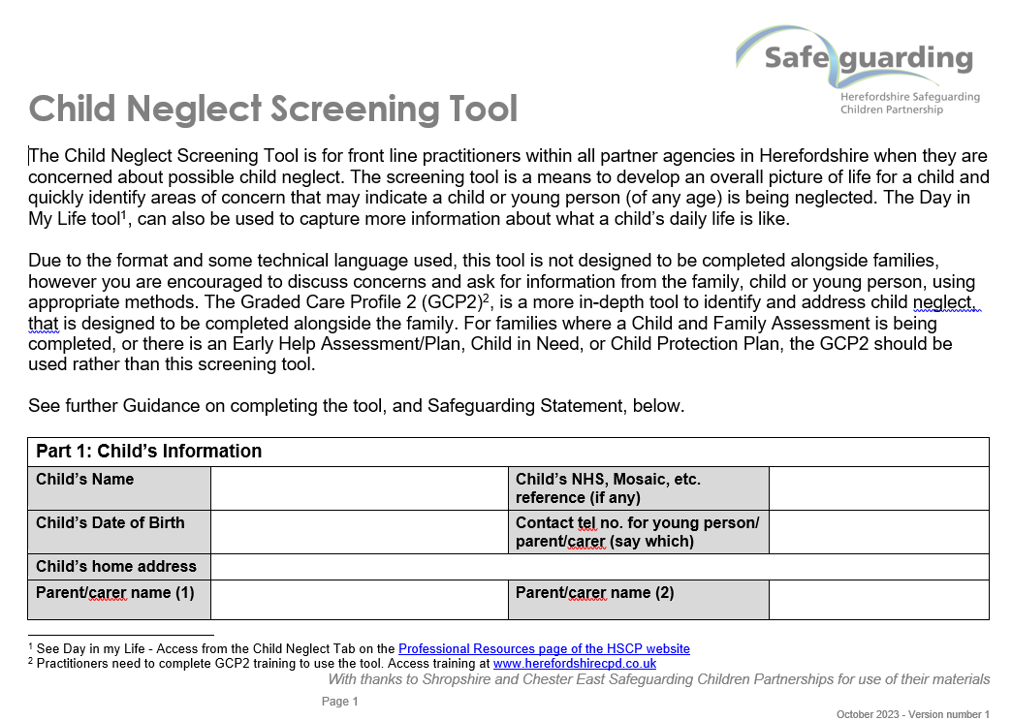

The new child neglect tools and resources are accessible on the partnership website’s [**Child Neglect Practitioner Resources**](https://www.herefordshiresafeguardingboards.org.uk/professional-resources/childrens-policies-guidance/child-neglect-practitioner-resources)page, and include:

* Neglect Quick Guide
* 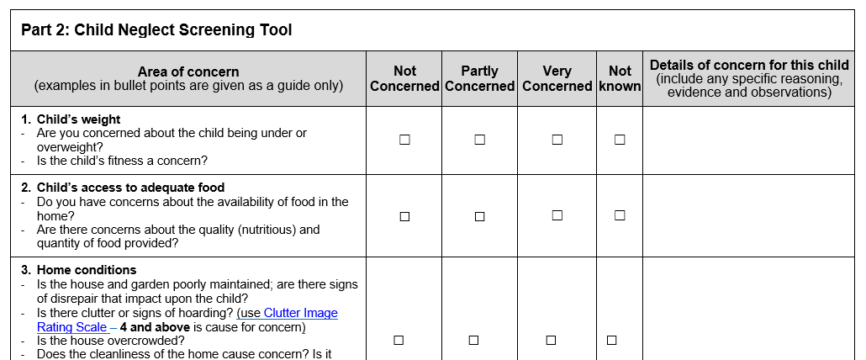Child Neglect Screening Tool
* A Day in My Life – templates and guidance on how to use it
* Multi-Agency Chronology Tool

**Impact:** 55 practitioners have attended the new Understanding Child Neglect course in 2023-24. Feedback from learners was that the course was very informative and they would recommend it to others. Learners also positively rated the Childhood Neglect Screening Tool, which is introduced during the course, and commented that it will be useful in practice.

Herefordshire is a licensed GCP2 authority and promotes the GCP2 tool for multi-agency professionals to work with families to identify and address child neglect. Following on from an impact review of GCP2 implementation in Herefordshire in March 2023, in 2023-24 the partnership implemented the recommendations from the review to strengthen GCP2 practice. This included:

* Revising the GCP2 training materials to emphasise that GCP2 should be used as a continuous tool in the support and plans for the family,
* Creating a mailing list of trained GCP2 practitioners, to keep in touch, promote training and learning opportunities from the NSPCC and HSCP, share updates and information about support for families,
* Introducing a GCP2 refresher module, for trained practitioners to reflect on their practice and seek guidance from a GCP2 trainer,
* Introducing addition tools, resources and training to support practitioners to identify and respond to child neglect (see below).

While the GCP2 review also recommended strengthening recording of GCP2 on children’s services case management system Mosaic, this recommendation did not progress due to capacity in the children’s services performance team and changes in management.

**Impact:** While attendance on GCP2 courses in 2023-24 had begun to decline, there are signs of increased bookings on GCP2 courses in 2024-25. This may be attributed to the activity to strengthen GCP2 practice, and the introduction of the Understanding Child Neglect course, which is helping to raise awareness of GCP2 and the resources available to support families**.**

## Effectiveness of the Multi-Agency Safeguarding Hub (Strategic Plan Priority – Right Help Right Time)

Following the OFSTED inspection in July 2022 which identified that some children were not receiving the right help at the right time the Multi-Agency Safeguarding Hub (MASH) Strategic Group and their Operational Group were refocused to ensure that the following key priorities were completed.

* The group drives the agenda to ensure that the service has a strong, robust front door aligning to partnership ‘Right Help Right Time’ (RHRT) agenda.
* The development of an integrated effective and efficient MASH is a key priority for the partnership in response to recent evidence of the need to refresh the current provision.
* The group will drive the work priorities for the MASH Operational Group which overseas monitoring of implementation for threshold and use of RHRT.
* The group will drive the agenda for an integrated MASH with new operating procedures, review of RHRT and training delivery across the partnership.
* The group has also commissioned the operational group to undertake audits of strategy meetings/ section 47 as part of its quality assurance function.
* The group will oversee the re-launch of the new RHRT/Multi-Agency Referral Form (MARF).

The co-location of the MASH has continued to bring about improved working relationships and dynamic conversations take place. There has been no change with capacity with police and education. Health have an additional post and there are now two health MASH posts. This is in recognition of the demand and increase in work. The extra posts allow for flexibility and to further develop the role of health in this area.

Children’s Social Care capacity is currently: 2 x Social Work Managers, 2 x Managing Practitioners and 6 x screening Social Workers. These posts should all be filled with permanent staff by the end of September 2024.

The MASH Group continues to meet monthly and undertake audits followed by learning circles to discuss the findings and dissemination to the respective organisations. The audit plan is being adhered to and we have full partnership engagement.

During this reporting period the MASH Operational Group has addressed the question of whether the MASH should accept responsibility to pass on referrals to other Local Authorities in cases where the child/young person do not live in the area, including where we have no involvement with the family. Partners were in agreement that this practice is one that cannot be supported as Herefordshire MASH cannot be responsible for another agency’s information. Clarity was provided about the circumstances in which the MASH would be involved and this is where a child is at risk of significant harm and there has been a child protection matter arising in Herefordshire that requires an immediate response. This is in line with Working Together and will be dependent on individual circumstances.

MASH education implemented Designated Safeguarding Lead coffee mornings in September 2023 and the current focus is now on early years engagement.

A multi-agency MASH review was conducted at the end of January 2024 led by the Head of Service for Quality Assurance, with strategic partners playing a key role alongside Leeds, our improvement partners. The report has been presented to and discussed at the Safeguarding Partnership Board, MASH Operational Group, Quality and Effectiveness Group and Children Social Care Senior Management Team.

The recommendations from the MASH review have been implemented. The traffic light system has been made clearer and more aligned with ‘Right Help Right Time’ (RHRT) threshold document. All ‘Greens’, early help are going directly to the Children’s Help and Advice Team (CHAT) to progress with MASH focusing solely on ‘Ambers’ and ‘Reds’. The impact has been a reduction in the workflow to MASH with children and families receiving the right help at the right time. The MASH Team Managers continue to reduce the amount of information in contact and referrals, so moving away from mini-assessments to summaries. Partners have visited two other areas, Telford and Wrekin and Dudley to look at their MASH. These visits were positive and we were able to share good practice. Finally, the MASH Team has strengthened its contribution to the delivery of RHRT training and now offer two Team Managers and two practitioners to support this area of work.

A meeting was held with a representative from our performance team about the data being presented to the MASH Operational Group. This has now been agreed with the focus solely on MASH and excluding data from other service areas.

Timeliness in progressing contacts to referrals has significantly improved and for the past 6 months this has been above 90%. The volume of referrals progressing to assessments have steadily decreased and we are more in line with our statistical neighbours.

Work has been completed to streamline the MASH processes. A new streamlined process for Early Help has been implemented which has removed duplication of work. Referrals at Level 2 of our Right Help Right Time threshold document are now sent directly to CHAT. The impact has been immediate and has freed up the work of the MASH social care who can now focus on the children that required a statutory response.

An on-line MARF is also being developed and we aim to complete this piece of work by September/October 2024. Alongside this, the website is being reviewed to ensure that guidance on what constitutes a good referral and what happens after a referral is made is available for referrers. Information on Early Help will naturally be a part of this.

The new terms of reference for MASH Operational Group, to reflect the change in governance and reporting has been completed.

In summary, the number of contacts and referrals are showing a downward trajectory and we are more in line with our statistical neighbours and West Midlands, particularly when compared to last year. There is further work to be done in this area with partners applying the RHRT threshold when referring in.

In the coming period we also need to consider how we report on call handling, e.g. our response times as we do not currently have any data on this. It is critical we better understand our performance in this area, for example the volume, response, dropped calls, etc.

## Multi-Agency Case Audits and Assurance

There have been three multi-agency audits completed by partners within the Quality and Effectiveness Group during this reporting period. A brief summary of each is provided below.

### Strategy Meetings Multi-Agency Audit

This dip sample audit of strategy meetings was agreed as a result of concerns regarding the accuracy of data recording in relation to agency attendance and quoracy. The aims of the audit were to determine whether strategy meetings were quorate and had a multi-agency approach with Social Care, Police and Health as a minimum in attendance, review the quality of the strategy discussion minutes, consider whether the decision and agreed actions were clearly recorded, evidence safety planning and identify any system or process issues which need to be addressed.

Thirty cases where the strategy meeting had been recorded as ‘not quorate’ were selected at random. Closer examination of these cases revealed that the vast majority of these meetings had in fact been quorate, indicating limitations in the recording of attendance at strategy discussions, so leading to inaccuracies in performance data. Learning was also identified in relation to safety planning, and the quality and distribution of the strategy meeting minutes.

### Child Sexual Abuse Multi-Agency Audit

This audit was commissioned following a recognition that there had been a need to improve multi-agency involvement and follow up in a number of cases identified by Children’s Social Care. Six cases were audited using the Joint Targeted Area Inspection (JTAI) audit tool. The audit identified a number of areas of emerging good practice, for example internal communication within agencies was regularly highlighted as a strength, a number of the cases showed evidence of assessments being written directly to the child and clearly took into account the voice and needs of the child, there was positive feedback with regards to sexual abuse training provided through Wye Valley NHS Trust, and that CAMHS input, where required, had been positive with clear evidence of hearing the voice of the child who is integral to the care planning.

A number of areas for improvement were also identified however, for example strategy meetings not always been called when appropriate, assessments not considering the ethnic and cultural identity of the child/young person or their family, delay in agreed actions being completed and the need to strengthen management oversight of cases. A programme of training on responding to sexual abuse has been commissioned in 2024-25.

### Child on Child Abuse Multi-Agency Audit

This audit considered children referred to Herefordshire Children’s Services Multi Agency Safeguarding Hub (MASH) and subsequently screened as level three and four referrals (based on [Herefordshire Right Help Right Time Levels of Need](https://view.officeapps.live.com/op/view.aspx?src=https%3A%2F%2Fwestmidlands.procedures.org.uk%2Fassets%2Fclients%2F6%2FHerefordshire%2520downloads%2FRight%2520Help%2520Right%2520Time%2520Levels%2520of%2520Need_2_2024.docx&wdOrigin=BROWSELINK)). Ten children’s files were audited relating to referrals made between June and November 2023. The cohort included seven alleged child victims and three children alleged to have caused harm. The audit included West Mercia Police, Herefordshire and Worcestershire Health and Care Trust, and Herefordshire Children’s Services (Safeguarding and Quality Assurance). The audit considered whether the referral was screened correctly at the point of referral, the prevalence and quality of strategy discussions, safety planning and risk assessments, how the voice of the child was captured and the strength of collaboration between agencies.

The audit identified that screening through the MASH is working well, with referrals being screened at the right level. The voice of the child is present, although there is scope for this to come through stronger, and in a more meaningful way. Agencies were seen to be working well together and knew the child and family well. This enables active and meaningful contribution. In relation to strategy meetings, it was identified that not all were taking place within timescales or were completed as a joint activity for both young people involved, however they were generally quorate. The audit also highlighted the importance of threshold decision making being clearly evidenced within the chair’s summary, and where professionals have disagreed, this needs to be clearly recorded. Finally, outcomes of referrals are not always shared with referring agencies.

In relation to the learning from these multi-agency audits, action plans are in place to address the identified areas for learning, and progress against these will be monitored within the Quality and Effectiveness Group.

### “Walk the Floor” and Staff Observation

Multi-agency **‘walk the floor’ and staff observation** activity was introduced to contribute to the quality assurance of safeguarding arrangements in Herefordshire, to provide intelligence to the HSCP about what is working and what is not working in terms of safeguarding arrangements at a practitioner level across Herefordshire, to assist the partnership in their common understanding of how child protection arrangements in Herefordshire operate across services, to promote the work of the HSCP and to share good practice. A number of these visits have been completed by members of the Quality & Effectiveness Group and findings reported back to the group.

**Impact:** Through multi-agency case auditing and Walk the Floor staff observations, we have a more detailed understanding of the quality and effectiveness of multi-agency safeguarding of children and young people in specific areas, and clear plans to address areas for development.

## Learning from Child Safeguarding Practice Reviews

The Joint Case Review Group is made up of multi-agency partners and oversees all case reviews undertaken. This includes Safeguarding Adult Reviews (SAR), Child Safeguarding Practice Reviews (CSPR) and Domestic Homicide Reviews (DHR). Cases that are considered for case review which do not meet criteria are also processed through the group to ensure any learning identified is actioned. The group also reviews national case reviews and seeks assurance across the system that learning has been embedded in systems and practice.

Three Rapid Reviews under Working Together 2018 were undertaken in 2023-24, one of which progressed to a [Local Child Safeguarding Practice Review, “Child HN,”](https://www.herefordshiresafeguardingboards.org.uk/wp-content/uploads/2024/03/Final-Report-LCSPR-Child-HN_Herefordshire-January-2024.pdf) which was published in March 2024. Upon completion of each Rapid Review, the partnership publishes a learning briefing, outlining the key learning for multi-agency practitioners. Recommendations for improvements to practice and systems are also identified and assigned to a lead person/agency to progress. Progress of these actions is monitored by the Joint Case Review Group.

### LCSPR “Child HN”

**LCSPR “Child HN”** was published in March 2024, with the Rapid Review having been completed in April 2023. The LCSPR identified six findings and six key learning points which then correlated to nine recommendations to strengthen current professional practice. While recommendations were for Herefordshire, as the case included agencies from Worcestershire, it was recommended that the Worcestershire Safeguarding Children Partnership consider the recommendations as well. In response to this learning, the HSCP and/or its partners have:

* Disseminated learning following the completion of the Rapid Review through a published learning briefing. Single agency staff presentations were also delivered to Children’s Social Care (staff briefing) and at the Wye Valley NHS Trust’s Safeguarding Forum.
* Delivered a presentation on risk to children from poor diabetes management at the partnership’s Practitioner Forum in October 2023.
* Delivered a presentation on the published LCSPR learning at the partnership’s Practitioner Forum in April 2024, attended by over 90 practitioners. Presentation slides from this presentation and a recording were also published online, to support onward dissemination of learning within each agency.
* Reviewed Elective Home Education procedures to strengthen links with families who electively home educate, and to better identify children who may become more vulnerable through home education.
* Strengthened Child in Need processes, including revising the Child in Need template and plan, and ensuring that minutes of Child in Need meetings are disseminated following meetings.
* Wye Valley NHS Trust are piloting the introduction of youth workers into the Diabetes and Epilepsy teams, to support young people transitioning into adult services. They are also identifying ways to introduce psychological support for children into the diabetes team.
* The Community Safety Partnership has secured a resource for minute-taking of MARAC meetings, which are now minuted.

### Rapid Review “Non-Accidental Head Injury to a Baby”

**Rapid Review “Non-Accidental Head Injury to a Baby”** was completed in April 2023, with eight recommendations identified. In response to this learning, the HSCP and/or its partners have:

* Published a Learning Briefing that was disseminated widely among partner organisations. This highlighted learning in respect of child neglect and cumulative harm, engaging with parents, and information sharing particularly during case closures or hand-overs.
* Single agency staff presentations were delivered to Children’s Social Care (staff briefing) and at the Wye Valley NHS Trust’s Safeguarding Forum.
* The Guidance on Child Protection Medicals and Health Assessments was reviewed to strengthen guidance on considering siblings and other children in the home.
* Monthly case review meetings have been set up between Health Visiting and the Peri-natal Mental Health team to discuss caseloads and open cases where the patient is not engaging with support or is starting to disengage.
* Hand-overs between Midwifery and Health Visiting have been reviewed to strengthen information sharing.

### Rapid Review “Toby”

**Rapid Review “Toby”** was completed in October 2023. In response to the learning, the HSCP and/or its partners have:

* Published a Learning Briefing that was disseminated widely among partner organisations. This highlighted learning in respect of young people’s access to butane gas for organised activities, ensuring that Out of Hours procedures are followed for safeguarding referrals, strengthening assessment practice in respect of understanding the cumulative effect of parental acrimony and parental substance misuse, and the importance of speaking directly with children.
* Single agency staff presentation was delivered to Children’s Social Care (staff briefing).
* HSCP sought assurance from the MASH, West Midland Ambulance Service, and West Mercia Police, of procedures when safeguarding referrals are sent/received out of hours, to ensure that the referrer knows to call the MASH out of Hours Duty number for urgent referrals.
* HSCP sought assurance from the local Army Cadets on use of butane gas for cadets’ excursions. The HSCP received assurance that strong processes were in place to prevent young people accessing butane gas.

In addition, four Rapid Review scoping meetings were convened for Safeguarding Adult Reviews and Domestic Homicide Reviews, one of which was progressed to a Domestic Homicide Review, and one to a combined Safeguarding Adult Review / Domestic Homicide Review.

Within the recommendations from these Rapid Reviews, learning was identified that impacted on safeguarding practice with children and families. This included:

* Improving practitioners’ understanding of the Mental Capacity Act and duty to carry out assessments – Mental Capacity Act courses are being offered for multi-agency practitioners. Courses started in March 2023 and will continue through 2023-24. These courses have been advertised to practitioners who predominantly work with children, as well as with adults.
* Promoting a Think Family approach – HSCP is leading the development of a Think Family approach in Herefordshire and has invited feedback from the Herefordshire Safeguarding Adults Board.
* Strengthening of the Complex Adults Risk Management (CARM) process – this is underway in 2024-25, led by the Herefordshire Safeguarding Adults Board.

The Joint Case Review Group recognises that evidencing the impact from reviews remains a challenge. In addition, work is needed to improve the quality of scoping documents received from agencies for Rapid Reviews, as these are often very detailed, without the analysis required. An advice and guidance session is planned to support those completing scoping documents to ensure analysis is present, to inform the scoping process.

**Impact:** Herefordshire has effective processes in place to complete Rapid Reviews and LCSPRs, with the three Rapid Reviews and one LCSPR in 2023-24 completed within timescales and with positive comments from the National Panel. This enables learning to be identified and acted upon in a timely way, which is improving safeguarding systems for children and young people.

## Multi-Agency Learning and Development Programme

In 2023-24, Development and Practice Group progressed the priority areas of the HSCP Learning and Development Strategy (2023-25). The priority areas for learning and development were:

* **Child Neglect** – As noted above, a new Understanding Child Neglect course was introduced to the multi-agency training programme, alongside the publication of a series of resources and tools to support practitioners to identify and respond to child neglect.
* **Child Exploitation / Contextual Safeguarding** – As noted above, Get Safe was launched and information was incorporated into the partnership’s multi-agency Exploitation and Vulnerability course. Trainers from different organisations also delivered Get Safe training within their staff groups.
* **Trauma-Informed Practice** – With funding from Public Health and the NHS ICB, *SaferTogether* were commissioned to deliver courses on Trauma-Informed Practice. The courses offered were: Trauma-Informed Practice – Principles and Foundations, and Creating and Supporting Trauma-Informed Organisations. These courses were designed to support the embedding of Restorative Practice approaches, and in response to findings of the Independent Commission to Consider Families’ Experiences of Children’s Services in Herefordshire.

### Multi-agency training programme

In addition to the three priority areas for learning and development, a broad safeguarding training programme is in place that is well attended by multi-agency professionals.

In 2023-24, **1372 learners** attended multi-agency safeguarding courses. The breakdown of courses and attendance is below:

|  |  |
| --- | --- |
| **Event** | **Attended** |
| **Early Help** | |
| An introduction to early help and services available to support families | 20 |
| Early Help Assessment - How to run effective team around the family meetings (TAFs) | 5 – *Full attendance not available* |
| Early Help Assessment writing workshop | 62 |
| **Substance Use** | |
| Delivering substance use brief interventions: Working with Young People | 17 |
| Overdose Awareness and Naloxone training | 62 |
| **Exploitation and Contextual Safeguarding** | |
| Exploitation & Vulnerability | 64 |
| **Child Neglect** |  |
| Understanding Child Neglect (HSCP Course) | 55 |
| Neglect Training (Commissioned course - before HSCP Neglect course was live) | 21 |
| Graded Care Profile 2 (GCP2) Training | 40 |
| Graded Care Profile 2 (GCP2) Refresher | 10 |
| **Safeguarding** | |
| Right Help Right Time | 63 |
| Working Together to Safeguard Children - Herefordshire | 60 |
| Working Together to Safeguard Children - Level 3 for Designated Safeguarding Leads / Named Professionals | 80 |
| **Trauma-Informed Practice** | |
| Trauma-Informed Organisations: Creating and Supporting a Trauma-Informed Organisation | 10 |
| Trauma-Informed Practice - Principles and Foundations | 162 |
| **Domestic Abuse Courses** | |
| Curiosity Saves Lives - Domestic Abuse Multi-Agency Training | 79 |
| Raising Awareness of Male Survivors of Domestic Abuse | 13 |
| Understanding Stalking and Harassment | 30 |
| Violence against Women and Girls | 12 |
| Working to address Housing Issues | 10 |
| Domestic Abuse and Learning Difficulties in Adults | 15 |
| Domestic Abuse and Older People | 34 |
| Domestic abuse and the Rural context | 14 |
| Domestic Abuse and Trauma | 56 |
| Domestic Abuse and Young People's Relationships | 62 |
| Honour Based Abuse including Female Genital Mutilation and Forced Marriage | 21 |
| Impact of Domestic Abuse on Children and Young People | 63 |
| MARAC (Multi Agency Risk Assessment Conferences) Awareness Training | 23 |
| **Additional Courses** | |
| LADO Training | 67 |
| Mental Capacity Act 2005 and DOLS - Understanding and Application | 17 |
| Practical considerations for effective practice with Gypsy and Traveller families | 41 |
| Solihull Approach 2-day Foundation training | 45 |
| Special Educational Needs (SEN) and Education, Health Care plan (EHCP) workshop | 39 |
| **TOTAL** | **1372** |

HSCP courses are attended by professionals from a range of organisations, with the highest attendance from Herefordshire Council employees, followed by Health professionals, Education professionals, and the Voluntary and Community Sector.

The following table provides a breakdown of attendance by organisation:

|  |  |
| --- | --- |
| **Organisation Type** | **Number of Professionals who Attended Partnership Courses** |
| Adult Care Provider (Independent) | 34 |
| Probation Service | 6 |
| West Mercia Police | 15 |
| West Mercia Youth Justice Service | 7 |
| Education | 274 |
| Foster Carers, Residential care children, Childminders | 79 |
| Fire and Rescue Service | 8 |
| Health | 302 |
| Herefordshire Council | 415 |
| Housing Providers | 44 |
| Other | 12 |
| Voluntary and Community Sector | 176 |
| **TOTAL** | **1372** |

In December 2023, the partnership was notified that West Mercia Police would be discontinuing its offer to deliver the Working Together to Safeguard Children “Level 2 – practitioners” and “Level 3 – safeguarding leads” multi-agency safeguarding training. In response, Development and Practice Group members confirmed their commitment to delivering these courses, and decided to re-launch the courses with a pool of multi-agency trainers from partner organisations. It was also decided to merge the Right Help, Right Time course with the “Level 2” safeguarding course. The new trainers have been identified and are reviewing the course materials, with a plan to re-launch the courses in September 2024.

At the end 2023-24, the partnership recognised that course attendance was being impacted by a large number of ‘no shows’ – delegates who register for a course but do not attend or cancel their place in advance. The Development and Practice Group will review data on ‘no shows’ in 2024-25, to identify actions that can be taken to improve attendance rates.

### Learning Events

One Practitioner Forum was held in 2023-24. While the partnership aims to deliver at least 2 Practitioner Forums each year, this was fewer in 2023-24 due to capacity within the Partnership Team, and because the Easter holiday fell at the end of March 2024, which meant that the Spring Practitioner Forum was moved to April 2024.

Approximately 50-60 delegates attended the October 2023 Practitioner Forum, which heard presentations about:

* Diabetes management in children and safeguarding,
* Launch of Child Neglect Tools and Resources,
* Care Act Assessments and Mental Capacity,
* Drugs and Alcohol Awareness and services provided by substance use provider Turning Point

In June 2023, two Partnership Team Officers attended the schools Designated Safeguarding Leads (DSLs) event, on the invitation of the education safeguarding team. This was an opportunity to raise awareness of the partnership’s work with school DSLs.

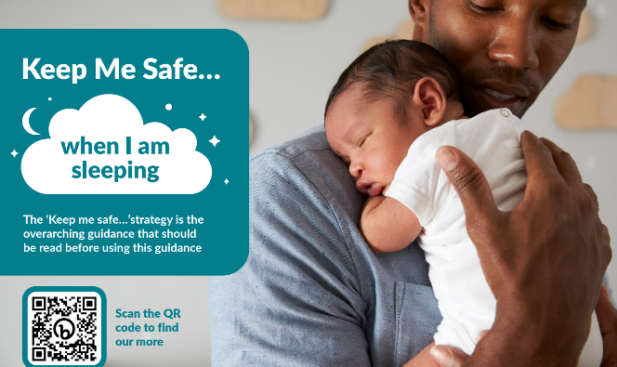Further, launch briefings were held for the *Keep me Safe Strategy* and *Keep Me Safe…. When I am Sleeping* guidance, with 155 practitioners attending from Herefordshire and Worcestershire.

The purpose of the Keep Me Safe Strategy is to provide consistent and co-ordinated messages to practitioners across Herefordshire and Worcestershire about a particular safeguarding theme to reduce the numbers of children who are seriously injured or die. *Keep Me Safe … When I am Sleeping* provides guidance and resources on looking after babies during night time and nap time.

### Learning briefings

In response to a learning need identified by Children Social Care, resources on Sexual Abuse and Honour-Based Abuse were disseminated to the workforce in September 2023. A 7-minute learning briefing on Honour-Based Abuse was also developed and disseminated.

In addition, 7-minute learning briefings were published about the learning from the three Rapid Reviews that were undertaken in 2023-24.

### The Partnership Bulletin

The bi-weekly Partnership Bulletin is used consistently as a means to disseminate news and information. The mailing list has grown to nearly 1000 subscribers, and the partnership regularly receives feedback on the usefulness of information shared in the bulletin.

**Impact:** A robust learning offer, that is well attended by partner agencies, provides practitioner in Herefordshire with the opportunity to keep their knowledge up to date, and reflect on their practice.

## Multi-Agency Professional Differences

Since the relaunch of the Multi-Agency Professional Differences Policy in September 2022, the number of escalations notified to the partnership has increased. **In 2023/24, there were 11 escalations** notified to the partnership. Although this offers reassurance that the policy is more widely known across the partnership and that practitioners feel confident in using it, there is no comparative data to indicate what an expected figure should be. It is therefore important that we also focus on the effectiveness of the process and resolution, and whether that has a positive impact on the safety of the child/young person involved in each case.

The partnership’s new method for logging and reporting on multi-agency escalations has enabled a better understanding of how professional differences are resolved. A review of escalations in the last four years was completed in October 2023, with a more in-depth analysis of escalations raised since the policy re-launch. This review found that:

* There has been an increase in escalations notified to the partnership since the policy re-launch in September 2022.
* There is some evidence that professional differences are being resolved at early stages of escalation, with the majority of “Stage 2” escalations resolved at “Stage 2.”
* Where escalations reached higher stages of the escalation process, this was often due to drift and delays in the response from the responding agency.
* The professional differences policy appears to primarily be used by schools and health partners, with children’s services the recipient of most escalations. There may be a need to explore awareness of and barriers to raising professional’s differences from other agencies, including police.

The HSCP Multi-Agency Professional Differences Policy is due for review in September 2024. Findings from the review of professional differences, and feedback from partner agencies on their experience of raising/receiving escalations, will be used to inform the policy review.

**Impact:** Herefordshire is seeing an increase in the use of the local multi-agency professional differences procedure. The review of professional differences completed in October 2023 also provided evidence that escalations raised were making a difference to improve outcomes for children:

**Case Example 1 –** Following an escalation from school with concerns that the agreed plans for the child were not being followed and there was a lack of response from the social worker and manager to discuss the concerns, a meeting with family, school, education safeguarding and social worker took place to agree the plan. The school will continue weekly safe and well checks and encourage gradual return to school; CSC will work with mum and grandmother about not exposing the child to their disputes. Regular network meetings were agreed to progress plan. The school said that the situation has improved and it was “good to get issues out in the open.”

**Case Example 2 –** Concerns were raised by Health about the efficacy of a Child in Need plan for a child who had self-harmed and been admitted to the paediatric ward. There had been multiple admissions to hospital in the past year and concerns that parents delayed calling an ambulance. Wye Valley NHS Trust requested a Strategy Discussion, and raised an escalation when there was a delay in response / scheduling of Strategy Discussion. A Strategy Meeting was held and children were made subject to s47 enquiry, with a plan to progress to ICPC.

## Multi-Agency Policies and Procedures

The HSCP maintains multi-agency policies and procedures, and works with the West Midlands Regional Safeguarding Procedures Group to maintain additional regional procedures.

In 2023-24, the following local multi-agency procedures were reviewed and strengthened:

**Guide to Child Protection Health Assessments (CPHA) and Child Protection Medicals (CPM).** Recognising that there was a back log of child protection health assessments, and the right process needed to be agreed to ensure that children were seen within timescales, the revised procedures reflected the following changes:

* A rationale to be put forward at ICPC relating as to whether a child needs a CPHA at that time.
* If health needs emerge after/between conferences then the appropriate medical professional can see the child. This might be the GP, allocated acute paediatrician or community paediatrician depending on the nature of the health concern.
* There is clearer guidance about the need to consider if CP Medicals should be undertaken for siblings or other children in the home who may have been exposed to abuse – this was in response to the findings of a Rapid Review.

**MARF (Referral Form), Standards for Completing a MARF, and MASH Information Sharing Guidance.** These documents were updated to simplify and clarify the MARF (Referral Form), as well as to clarify guidance on information sharing and consent.

**Right Help, Right Time – Levels of Need Policy.** The Right Help, Right Time Levels of Need Policy was updated with the following changes made, pending a full review in line with Working Together 2023:

* Updated information about services and procedures
* Reviewed guidance on consent
* Updated Practice Framework to reflect Restorative Practice.
* Clarified level of support for children with Special Education Needs and children with disabilities.
* Clarified threshold examples for: FGM, use of “stress positions”, children who are pregnant, and gang affiliation.

**Multi-Agency Child on Child Abuse Guidance.** This document was updated, although no changes were made to the substance of the guidance:

* “Peer on Peer” abuse changed throughout to “Child on Child”
* Updated web links.

In addition, as referenced above, the **Child Exploitation / Contextual Safeguarding** tools and guidance were reviewed to reflect the Get Safe approach.

**Impact:** Herefordshire has up to date multi-agency policies and procedures that respond to emerging needs and support practitioners to safeguarding children by offering a common framework on which to work alongside partners.

# Voice of Children and Families

The Voice of the Child Toolkit, published in 2022, remains a key tool to promote listening to children and young people in Herefordshire, and the HSCP continues to regularly promote the toolkit. In 2023-24, the voices of children and young people were heard through:

* Establishment of the “SAFE CADETS” – a group of young people who had experienced or been at risk of child exploitation, who provided feedback on and supported the implementation of the Get Safe approach for contextual safeguarding.
* The Independent Chair and Scrutineer attended the Corporate Parenting Panel, where children and young people spoke of their experiences of support from children’s services and partners agencies.
* The HSCP has listened to the voice of families who spoke to the Independent Commission to Consider Families’ Experiences of Children’s Services in Herefordshire, with the Independent Scrutineer also being an observer on the panel. The feedback from families that spoke with the Independent Commission has informed priorities and activity for the HSCP in 2023/24.

The HSCP has also begun the development of an Engagement Framework, that outlines how the HSCP and its partners will listen to children, young people, parents and carers, in direct practice as well as in shaping services. The HSCP Engagement Framework is expected to be approved in 2024.

# S11 Self-Assessment

In May 2023, Herefordshire Safeguarding Children Partnership ran a Section 11 audit exercise using the new West Midlands regional audit tool.

Partner agencies and practitioners engaged well with the overall process and feedback was relatively positive. For some agencies, this process built on safeguarding compliance that is already in place, for others it helped with understanding Section 11 (Children Act 2004) standards more clearly.

Overall, the findings from the Section 11 audit showed all agencies who completed their self-assessment scored an average rating of green (good/outstanding), giving assurance that they were compliant with their safeguarding responsibilities, with responses indicating good adherence to requirements. The audit told us that partners are clearly confident in their systemic and strategic work and planning; policies and procedures were by far the highest scoring criteria across the partnership. Areas for improvement tended to be within the person-centred aspects of work such as partners incorporating the voice of the child into their work. This suggests that all partners have strong frameworks within which their work is undertaken, and that future development should focus on ensuring staff, children and young people are able to shape and influence partnership culture and practice.

As a follow up to the Section 11 self-assessment process, two ‘Check and Challenge’ sessions were held, chaired by the Independent Scrutineer. These sessions provided the opportunity to challenge each other, discuss future improvements and learning, and share best practice. The methodology enabled each agency to present an overview of their S11 return, highlighting areas graded as inadequate or requiring improvement and focusing on mitigating actions and action plans.

As part of the Check and Challenge sessions the Independent Scrutineer also focused on individual agency’s responses to the Report of the Independent Commission to Consider Families’ Experience of Children’s Services in Herefordshire in relation to the question in the report: What will the Herefordshire Safeguarding Children Partnership do to ensure that the complaints procedures in every agency across the partnership are accessible to families, work well, and findings are recorded and acted on? All agencies that took part in the Check and Challenge sessions were able to evidence that they have complaints processes, managing allegations procedures, whistle blowing and escalation procedures in place. There was, however, varying evidence of the ability of all agencies to analyse learning from complaints in a systematic manner, and further consideration will need be given on how assurance in this area can be secured.

The Section 11 returns also identified areas of good and outstanding practice within agencies across the county. Areas of particular strength were to be found within internal accountability arrangements for safeguarding, the availability of written policies and procedures for safeguarding, promoting the wellbeing and protection of children and young people, staff understanding of how to report child safeguarding concerns, and robust safe recruitment processes.

In 2024-25, the partnership will monitor agencies’ progress in addressing recommendation and actions identified from the 2023 S11 Self-Assessment.

**Impact:** Through the Section 11 Self-assessment and follow up process we have a clear picture of the overall effectiveness of single agency safeguarding arrangements.

# Implementation of Working Together 2023

Following completion of two ‘Health Check’ sessions (December 2023 and March 2024), facilitated by the DFE National Advisor, the partnership has developed a comprehensive implementation plan to manage the changes introduced by ‘Working Together to Safeguard Children 2023.’ A method of monitoring individual agencies’ responses within the partnership has also been developed and will be an ongoing priority for the Safeguarding Partners during 2024.

With work starting in 2023-24 and progressing into 2024-25, a number of key decisions have already been made to support the implementation of Working Together 2023:

* The new DCS for Herefordshire Council has assumed the Chairing role of the Delegated Strategic Partners meetings.
* A plan for Independent Scrutiny is drafted and under review.
* The Delegated Safeguarding Partners agreed to increase the frequency of meetings from quarterly to 6-weekly, with meetings having a rotating thematic focus based on feedback from the HSCP subgroups, Budget, Governance and Performance, and Children’s Improvement Plan priorities.
* The Lead Safeguarding Partners have begun meeting and have agreed how they will fulfil their functions under Working Together 2023.
* Discussions have opened with education, via existing school forums, on how to strengthen engagement with education providers, including a proposal to establish a new education safeguarding sub group.
* The Joint Case Review Group has reviewed its procedures to reflect the requirement of Serious Incident Notifications of the death of a care leaver, and for representatives of the three Safeguarding Partners to jointly decide on cases that meet the criteria for a Serious Incident Notification.

# Funding

The three Safeguarding Partner agencies contributed to the Partnership Team budget for 2023-24, which also funds the work of the Herefordshire Safeguarding Adults Board and Herefordshire Community Safety Partnership.

In 2023-24, the three statutory partners’ agencies financial contributions totalled **£471,919**.

Due the cost of an external agency Partnership Manager in 2023-24, the Partnership Budget was overspent by £9,254. To fund these costs, the Partnership Team held one post vacant throughout the year (Partnership Administration Coordinator), and £9,254 was used from the partnership’s financial reserves to meet costs.

|  |  |  |
| --- | --- | --- |
| **Contributions** | | |
| **Agency** | **2023-24 Contribution £** | % |
| **Children and Families (Herefordshire Council)** | £155,763 | 33% |
| **Adults / Community Wellbeing (Herefordshire Council)** | £144,899 | 30.7% |
| **NHS Integrated Care Board** | £101,857 | 21.6% |
| **West Mercia Police** | £69,400 | 14.7% |
| **Total Contributions** | **£471,919** |  |
| **Spent from Reserves** | **£9,254** |  |
| **Total Expenses** | ***£481,173*** |  |

# Our Challenges

In 2023-24, the partnership was able to make progress against many areas that previously had posed challenge, including development of the multi-agency dataset, establishing a regular programme of multi-agency audits, and finalising the Child Neglect Strategy.

Our current challenges remain:

* With a revised Child Neglect Strategy, the challenge will be to ensure that this drives improved responses by partner agencies to reports of neglect, and better outcomes for children, young people and families where neglect is identified as a concern.
* We need to build on the multi-agency dataset, expanding the number of agencies contributing and focussing the range of indicators covered.
* We need to build on the capacity and availability of auditors across the partnership to ensure that the momentum gained in relation to our multi-agency audit activity can be maintained.
* We now need to ensure that the learning from our multi-agency audit activity is used effectively to improve both our safeguarding and child protection systems, and outcomes for children and young people.
* The ongoing challenge of improving the conversion rate for referrals from partner agencies to the MASH remains. The Right Help Right Time Levels of Need document review and relaunch will provide a further opportunity to make an impact in this area.
* We need to build on our understanding of the effectiveness of our local escalation procedure.
* We need to strengthen our approaches to listening to children, young people and parents/carers.
* Evidence of impact from case reviews remains a challenge.
* The roll-out of Restorative and Relationship practice with multi-agency practitioners has not kept pace with the roll-out for Children’s Social Care staff. This has led to some partners feeling left behind.

# Comment from the Independent Scrutineer

In 23/24 the partnership has delivered on a more consistent basis than previously was the case, which indicates that progress is being made and that the HSCP is establishing the right ‘architecture’ for an effective partnership. The challenge for 24/25 will be to maintain this progress in the face of other challenges such as staffing changes particularly at the leadership level. The plans developed for implementing WT23 provide sufficient evidence that HSCP leaders are aware of the challenges ahead and are taking the right steps to move forward. Pace of change is still being identified by the DfE Commissioner and Ofsted, and the latter also continues to challenge partnership effectiveness and engagement in practice. An emerging issue that needs addressing is that the restorative model of practice being implemented by Children’s Social Care need more engagement with and by partners. If it is to be the central defining feature of safeguarding practice in Herefordshire, this needs to be adopted by all involved.

# Priorities moving forward

In recognition of the progress made in key areas in 2023-24, and challenges remaining, the partnership is focussed on the following priorities in 2024-25.

**Leadership Priorities**

* Complete the alignment of the HSCP with requirements of Working Together 2023. This is also a priority in the Children’s Services Improvement Programme.
* Work with Herefordshire Council to support Phase 2 of the Children’s Services Improvement Programme.
* Support the promotion of Restorative and Relational Practice approaches with multi-agency partners, alongside promotion of the Think Family Approach. This is also a priority in the Children’s Services Improvement Programme.

**Quality Assurance Priorities**

* Continue the development of HSCP performance data set and analysis– funding has been agreed to support this through a shared Herefordshire and Worcestershire project, which will further increase the number of agencies contributing their child safeguarding information, and simplify the gathering, processing and presentation of that information to the partnership.
* Deliver a programme of multi-agency audits.
* Monitor agencies’ completion of actions identified in the section 11 self-assessment, and review section 175 audits of partners and schools compliance with safeguarding guidance and responsibilities.

**Case Review Priorities**

* Continue with the effective arrangements for Rapid Reviews and Local Child Safeguarding Practice reviews though the Joint Case Review Group.
* Focus on embedding the learning from case reviews.

**Herefordshire Policies and Procedures Priorities**

* Implement the HSCP Child Neglect Strategy.
* Agree and implement the HSCP Engagement Framework for Children, Young People, and Parents/Carers. This is also a priority in the Children’s Services Improvement Programme.
* Review and re-launch the Multi-Agency Professional Differences Policy. This is also a priority in the Children’s Services Improvement Programme.
* Review and re-launch the Right Help, Right Time Levels of Need policy, in line with Working Together 2023. This is also a priority in the Children’s Services Improvement Programme.
* Work with the Herefordshire Safeguarding Adults Board to strengthen the transition pathways for young people at risk of exploitation.

**Herefordshire Learning and Development Priorities**

* Re-launch the Working Together to Safeguarding Children Level 2 (practitioner) and Level 3 (safeguarding leads) courses
* Roll-out Restorative Practice training with multi-agency partners. This is also a priority in the Children’s Services Improvement Programme.
* Promote Think Family approaches across the multi-agency workforce. This is also a priority in the Children’s Services Improvement Programme.

**Partnership Team Priorities**

* Support the transition of the Community Safety Partnership support to a new team outside of the Partnership Team, allowing the Partnership Team to focus resources on the HSCP and Herefordshire Safeguarding Adults Board.

# Appendix A – HSCP Governance Structure

**Strategic Partnership Board**

**Chair: Director Children Services, Herefordshire Council**

**Quality and Effectiveness Group**

Performance, Case Audits, Quality Assurance, s11 oversight

**Chair: Service Director, Herefordshire Council**

**Joint Case Review Group**

SARs, CSPRs, DHR, and monitoring learning from reviews

**Chair: NHS ICB**

**Development and Practice Group**

Training, Practice Development, Policies & Procedures, Engagement with children and families

**Chair: Head of Service, Herefordshire Council**

**Child Exploitation and Missing Group**

Child Exploitation / Contextual Safeguarding, Get Safe Oversight

**Chair: Head of Service, Herefordshire Council**

**MASH Group**

Effectiveness of the MASH, MASH policies/procedures, Right Help Right Time Levels of Need

**Chair: Head of Service, Herefordshire Council**